AGM Agenda 2.11.22

- Members present
Dan Crow, Hannah Kelley, Phill Bird, Anton Newell, Paul Beasley, Susan Allcock, Lisa Knight, Julie Mitchell, Jordan Mitchell, Nick Burnside, John Knight, Matthew Lamb, Susan Chillingworth, Martin Vernon (joined at 7:35pm).

- Apologies for absence
Gary Bird, Terrie Theaker, Paul Whittingham, Fiona Green, John Dale.

- Minutes of the previous AGM
Agreed

- Matters arising
Have actioned points on changes to constitution and senior cross country and road captains. Claire has since stepped down as captain.

- Chair’s report – Gary Bird (read out by Dan Crow)

- Secretary’s Report – Hannah Kelley (read out by Hannah Kelley).

- Treasurer’s report – Anton Newell (report attached below)

- Mini League Cross Country – Julie Mitchell (read out by Julie)

- Mini League Track & Field – Julie Mitchell (read out by Julie)
Matt Lamb- enquired what officials are required? Julie- we need officials for a whole range of competitions from T&F to cross country, there are always jobs that need doing. Matt- could we maybe engage some of our older teenage athletes? Julie- Have tried and will sometimes get older U15’s helping out but not consistent.
Lisa Knight- Would a rota work? Asking parents just to do I event and can grow from there? Hannah- We are getting to a point where we will have to make it a condition of membership that parents have to volunteer other we will have to withdraw teams or cancel training. Sue C- at Rushcliffe they are told parents have to volunteer otherwise teams will not be entered. Dan- a lot of other organisations like Scouts and football clubs do this so we can look at this.
ACTION- to discuss at next committee meeting.

- Midland Mens /Ladies T&F – Hannah Kelley (read out by Hannah Kelley)
Matt Lamb- How long do we have to decide? Hannah- probably have a month or so. Dan- how far would the division 4 matches be? Hannah- there are 3 geographical divisions. Matt- the distance was definitely was a
Lisa- would having a home match be more advantageous?
ACTION- to discuss future of the Midland T&F league and inclusion of the Notts Development League at next committee meeting.

- Sportshall report – Julie Mitchell (read out by Julie Mitchell)

- Booth Decorators x Country Report – Phill Bird (read out by Phill Bird)

- Booths Decorators RRace Report - Phill Bird (read out by Phill Bird)

- Notts AAA Summer league- Joyce Stevens (read out by Julie Mitchell)

- YDL U/13 & U/15 T&F- Julie Mitchell (read out by Julie Mitchell)
Julie will be stepping back as team manager for this league. Hannah has already sent out an email asking for a replacement, but nobody has come forward. Julie happy to support in the set up and organisation. If we cannot get a new team manager, we may need to withdraw from the league. Dan- what is the deadline for confirming our place? Julie- it has already passed but we could still withdraw. Matt- do we know the dates? Julie- not yet but they do fit in with the EA calendar. Matt- what are the location of these competitions? Julie- within an hour usually.
ACTION: Matt Lamb to consider the position.

- North Mid Cross Country League- Joyce Stevens (read out by Julie Mitchell)

- Election of Officers

Position | Nominee | Nominated by | Seconded by
Chair | Dan Crow | Julie Mitchell | Lisa Knights
Vice Chair | Gary Bird | Dan Crow | Hannah Kelley
Secretary | Hannah Kelley | Dan Crow | Jordan Mitchell
Assistant Secretary | Lisa Knight | Hannah Kelley | Anton Newell
Treasurer | Anton Newell | Hannah Kelley | Susan Allcock
Membership secretary | Dan Crow/Phill Bird (as support) | Hannah Kelley | Julie Mitchell
Health and Safety officer (covid-19) | Nick Burnside | Dan Crow | Hannah Kelley
Welfare Officer | Jordan Mitchell and Joyce Stevens | Julie Mitchell | Hannah Kelley
Website and social media | Jordan Mitchell, John Kelley (to add Phill and Dan if possible)  Paul Whittingham, Jordan Mitchell, Hannah Kelley, Gary Bird, Dan Crow.
Auditor | Mick Davies (TBC)
Committee | All of the above nominees plus: Julie Mitchell, Susan Allcock, Nick Burnside, Paul Beasley, Lisa Staley, Matt Lamb.

Ladies captain Tracey Parker and Lisa Knight to take on temporarily until a replacement for Claire can be found

- A.O.B
Anton- Changes to membership. Anton recommending that the club reduce their membership by £1 to offset the increase being applied by EA to keep the cost the same to members.
Action- To be discussed at the committee meeting.

John Knight- Trustees, indoor access and future of midland league.
Hannah- No access to indoor facilities. Lisa- are we paying less? Phil- We never officially paid for indoor. Hannah- trustees are no longer required within our new constitution. Midland league to be discussed at the next committee meeting.

Hannah Kelley- New constitution. This was emailed out for members to vote for/against. Online votes 11 in favor. Phill- a lot of information on the email so some people may have missed the information.
Vote: for = 25 (including online votes), against = 0, abstain = 0.

Meeting close 8:25pm
Date of next committee meeting: Monday 7th November

FINANCIAL ACCOUNTS
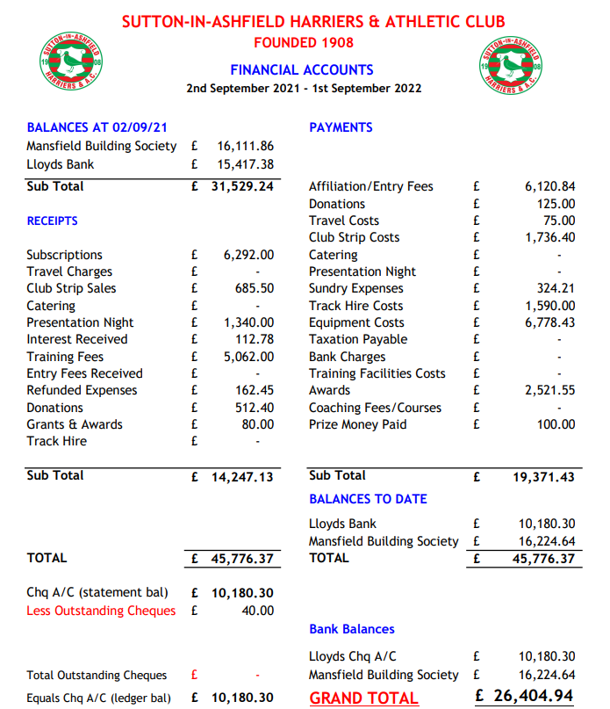

Chairmans Report

Another year has come and gone in what seems like the blink of an eye, I’m sure you’ll all agree it’s nice to have returned to the normality of club life and being back at the school and seeing athletes who have spent so long training and trained so hard finally back competing, again the club continues to go from strength to strength we’ve achieved some excellent results at competitions and it’s been amazing watching the athletes training and forging new friendships, the first aid kit and defib are now in the cabin luckily we’ve not had to use either but it’s a reassuring to know there should they be needed. Memberships are something that continue to grow although we’ve seen athletes not renew and leave to pursue other adventures we keep a steady flow of new athletes coming through especially in the younger ages were numbers have exceeded 20+ on training nights which is a refreshing change, the club continues to keep moving forward and going from strength to strength, items still on the agenda are to have the cabin roof repaired and also get some sort of lighting in the middle lock up for the dark nights, also something that has been discussed on training nights is getting our equipment out of the school and into the lockups for future use especially the sports hall equipment because we’ve had athletes going to competition blind but still pulling off some outstanding results imagine what can be achieved with a little practice and training. Finally thank you to all the committee members, officials, coaches, team managers and finally you the members without you the club simply will cease to exist, here’s to a good next 12 months Gary Bird Chairman Sutton in Ashfield harriers and AC.

Booth Decorators AGM Reports 2022

Booth Decorators Cross Country report for 2021/2022

As usual there were five races at various venues. Again, we were up against strong teams but turnout and team spirit was excellent in what were generally tough winter conditions. We had a good turn out in all races with some fine performances. The ladies who came 4th in their category whilst the men managed 5th position. Combined position 5th.

Individually, Michelle Wilcocks & Tracy Parker won their category with Dave Cass, Tanya Mace and Rosemary Arris-Pratt also securing prizes in their categories.

I would like to thank all those runners who took part for our team hope to see you all in future races.

Our Final Placing’s

Men ….. 5th Ladies… 4th Combined.. 5th

BDL 21/22 Cross Country Overall Standings
Overall |  |  |  |  | Overall
Place | Name | Total points |  |  | Place | Name | Total points
15 | David Cass | 70 |  |  | 1 | Michelle Holmes | 4
25 | Nick Burnside | 126 |  |  | 8 | Tracy Parker | 48
32 | Wayne Lowe | 160 |  |  | 21 | Claire Watson | 148
46 | Paul Hillman | 245 |  |  | 30 | Jackie Easom | 206
47 | Paul Castledine | 248 |  |  | 31 | Rosemary Arris-Pratt | 207
54 | Robert Roper | 310 |  |  | 34 | Leah Chillery | 235
60 | Martin Vernon | 342 |  |  | 38 | Tanya Mace | 287
72 | Anton Newell | 446
75 | Gary Bird | 473
79 | Rob Pearce | 506
 | M40 |  |  |  |  | F40
Place | Name | Total points |  |  | Place | Name | Total points
12 | Martin Vernon | 60 |  |  | 7 | Leah Chillery | 38
 | M45
Place | Name | Total points
2 | David Cass | 9
4 | Nick Burnside | 20
5 | Wayne Lowe | 25
9 | Paul Hillman | 43
15 | Rob Pearce | 83
 | M50 |  |  |  |  | F50
Place | Name | Total points |  |  | Place | Name | Total points
5 | Robert Roper | 37 |  |  | 1 | Tracy Parker | 4
7 | Anton Newell | 55 |  |  | 5 | Jackie Easom | 31
 | M55 |  |  |  |  | F55
Place | Name | Total points |  |  | Place | Name | Total points
4 | Paul Castledine | 12 |  |  | 2 | Tanya Mace | 24
 |  |  |  |  |  | F60
 |  |  |  |  | Place | Name | Total points
 |  |  |  |  | 2 | Rosemary Arris-Pratt | 8
 | MS |  |  |  |  | FS
Place | Name | Total points |  |  | Place | Name | Total points
24 | Gary Bird | 170 |  |  | 1 | Michelle Holmes | 4

Booth Decorators Road Race report for 2022

It was a good year for us against strong teams from Heanor, Belper and Long Eaton. We did have good turnouts in all the five races. It was pleasing to see new club runners taking part as we look forward to building on this base for the future.
We staged the first road race at Teversal Grange and the feedback was excellent on all counts. The course, venue and the overall organisation was very good so a special thank you to Paul Beasley and to all who helped out on a good night for Sutton.
The men had an excellent season and secured 2nd place again whilst the ladies secured 3rd place and giving us a combined finishing position of 2nd place. Individually, Sally Hughes, Tracy Parker, Dave Cass, Tim Clayton and Nick Luke won their categories with Michelle Holmes, Vicki Cotton, Dawn Stevenson and, Richard Robinson also securing prizes in their categories.

Our Final Placing’s

Men ….. 2nd Ladies… 3rd Combined.. 2nd

Sutton Age Group Positions BDL Derby Runner 2022 RR League
SL |  |  | SM
2 | Michelle Holmes |  | 6 | Lewis Boswell
10 | Claire Watson |  | 9 | Michael Cattermole
13 | Yvette Robinson |  | 36 | Alex Brewer
VL40 |  |  | VM40
7 | Gemma Bacon |  | 2 | Richard Robinson
10 | Nicola Sanderson |  | 5 | Chris Holmes
 |  |  | 8 | Jamie Ellis
VL45
1 | Sally Hughes |  | VM45
 |  |  | 1 | David Cass
VL50 |  |  | 5 | Wayne Lowe
1 | Tracy Parker |  | 10 | Mark Pidcock
3 | Vicki Cotton |  | 16= | Jose Colorado
VL55 |  |  | VM50
3 | Dawn Stevenson |  | 1 | Tim Clayton
 |  |  | 4 | Paul Castledine
 |  |  | VM60
 |  |  | 1 | Nick Luke
 |  |  | 7 | Tony Foreman
 |  |  | 9 | David Walsh
 |  |  | 18 | Steven Brewer
Individual results for all the races can be found on the club web site

Finally thanks to everyone who has been involved in the two leagues as we look forward to hopefully another good year.

Phill
Phillip Bird.

